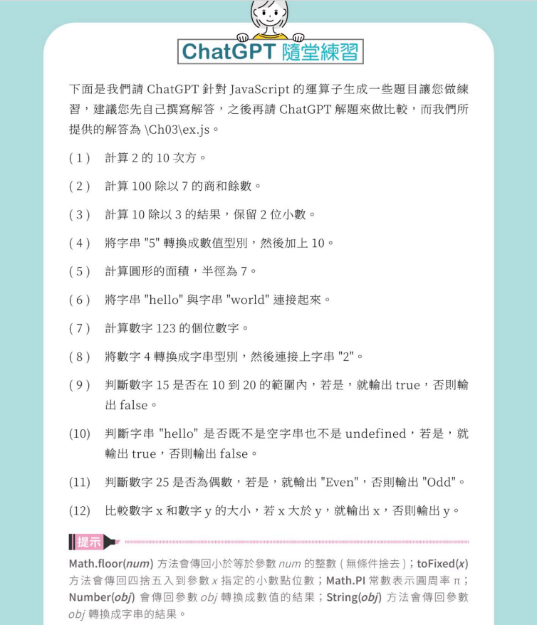

以下是12道習題的解答：

1. console.log(Math.pow(2, 10));
2. console.log(Math.floor(100 / 7));

console.log(100 % 7);

1. console.log((10 / 3).toFixed(2));
2. console.log(Number("5") + 10);
3. console.log(Math.PI \* 7 \* 7);
4. console.log("hello" + "world");
5. console.log(123 % 10);
6. console.log(String(4) + "2");
7. console.log(15 >= 10 && 15 <= 20);
8. console.log("hello" !== "" && "hello" !== undefined);
9. console.log(25 % 2 === 0 ? "Even" : "Odd");
10. console.log(x > y ? x : y);